**Class:** Final Year (Computer Science and Engineering)

**Year:** 2023-24 **Semester:** 1

**Course:** High Performance Computing Lab

**Practical No. 7**

**Name:** Sumit Narake

**PRN:**2020BTECS00023

**Batch :** B2

**Information:**

**MPI_Init:**

Description: Initializes the MPI environment. It must be called before any other MPI function.

Syntax: int MPI_Init(int* argc, char*** argv);

**MPI_Finalize:**

Description: Finalizes the MPI environment. It should be called when you're done with MPI operations.

Syntax: int MPI_Finalize(void);

**MPI_Comm_rank:**

Description: Retrieves the rank of the calling process within a communicator.

Syntax: int MPI_Comm_rank(MPI_Comm comm, int* rank);

**MPI_Comm_size:**

Description: Retrieves the total number of processes in a communicator.

Syntax: int MPI_Comm_size(MPI_Comm comm, int* size);

**MPI_Send:**

Description: Sends data from the calling process to another process.

Syntax: int MPI_Send(void* buf, int count, MPI_Datatype datatype, int dest, int tag, MPI_Comm comm);

**MPI_Recv:**

Description: Receives data into the calling process from another process.

Syntax: int MPI_Recv(void* buf, int count, MPI_Datatype datatype, int source, int tag, MPI_Comm comm, MPI_Status* status);

**Problem Statement 1:**

Implement a simple hello world program by setting number of processes equal to 10

Program:

#include <stdio.h>

#include "mpi.h"

int main(int argc, char *argv[]) {

    int rank, size;

    MPI_Init(&argc, &argv);

    MPI_Comm_rank(MPI_COMM_WORLD, &rank);

    MPI_Comm_size(MPI_COMM_WORLD, &size);

    if (size != 10) {

        printf("This program is intended to be run with exactly 10 processes.\n");

    } else {

        printf("Hello, world! I'm process %d of %d.\n", rank, size);

    }

    MPI_Finalize();

    return 0;

}

**Screenshots:**

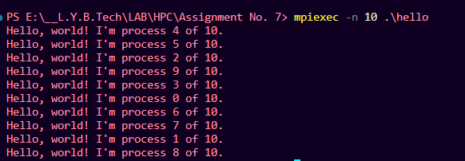

**Problem Statement 2:**

Implement a program to display rank and communicator group of five processes

**Program:**

#include <stdio.h>

#include "mpi.h"

int main(int argc, char *argv[]) {

    int rank, size;

    MPI_Comm new_comm;

    MPI_Init(&argc, &argv);

    MPI_Comm_rank(MPI_COMM_WORLD, &rank);

    MPI_Comm_size(MPI_COMM_WORLD, &size);

    if (size != 5) {

        printf("Rank: %d of %d processes in the communicator group.\n", rank, size);

        printf("This program is intended to be run with exactly 5 processes but you don't have sufficient processors.\n");

    } else {

        MPI_Comm_dup(MPI_COMM_WORLD, &new_comm);

        printf("Rank: %d of %d processes in the communicator group.\n", rank, size);

        MPI_Comm_free(&new_comm);

    }

    MPI_Finalize();

    return 0;

}

**Screenshots:**

